Introduction
Retail businesses generate a huge amount of sales data every day, including customer purchases, product categories, transaction time, and payment details. Analyzing this data is important to understand customer behavior, identify top-selling products, track revenue trends, and improve business decision-making.
This project focuses on performing Retail Sales Analysis using SQL by working with a structured sales dataset. The main objective is to extract meaningful insights such as total revenue, sales trends, best-performing categories, customer purchase patterns, and peak sales periods. Using SQL queries, the dataset is cleaned, explored, and analyzed to answer real business questions.
This analysis helps retailers make better decisions related to inventory management, product demand forecasting, customer segmentation, and overall sales growth.

Importing the data
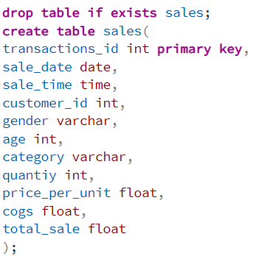
Data Cleaning
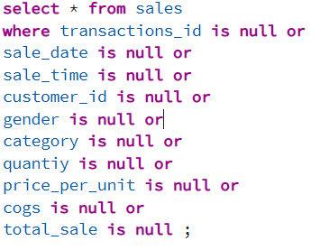
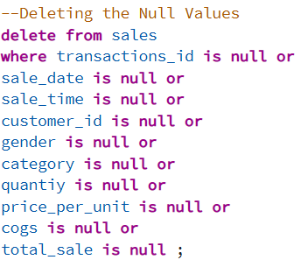
Data Exploration
1.How many sales we have
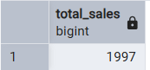
2. How many unique customers we have
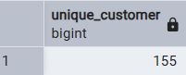
3.How many unique category we have
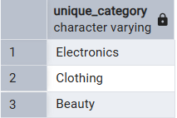
4. Write a SQL query to retrieve all columns for sales made on '2022-11-05
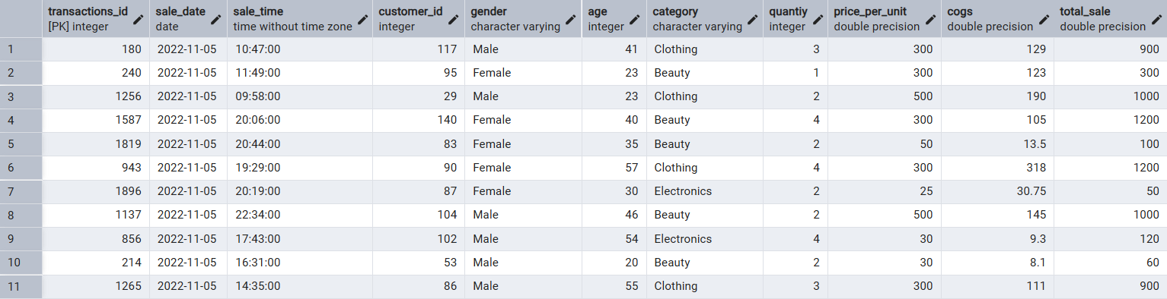
5. Write a SQL query to retrieve all transactions where the category is 'Clothing' and the quantity sold is more than 4 in the month of Nov-2022
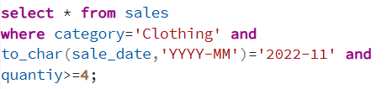
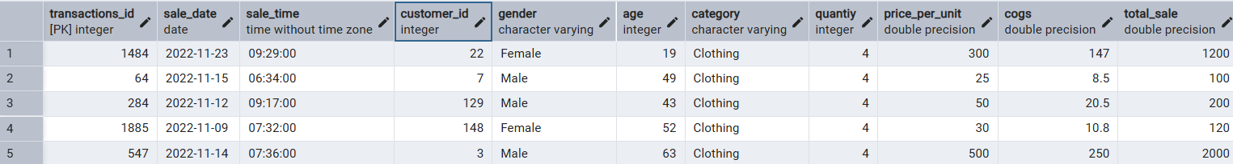
Total we have 17 records out of 1997 records
6.Write a SQL query to calculate the total sales (total_sale) for each category
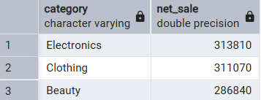
7. Write a SQL query to find the average age of customers who purchased items from the 'Beauty' category.
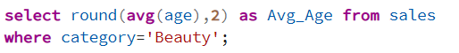
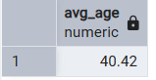
8. Write a SQL query to find all transactions where the total_sale is greater than 1000.
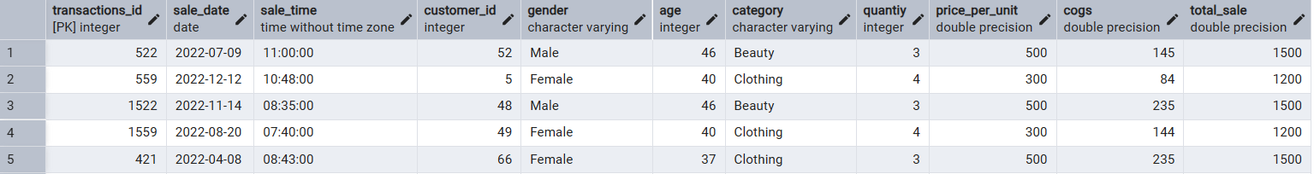
A total of 306 records were found where the Total_Sales value is greater than 1000
9. Write a SQL query to find the total number of transactions (transaction_id) made by each gender in each category.
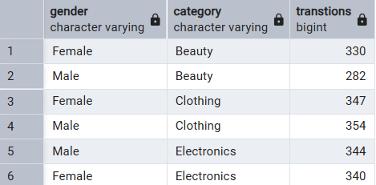
10. Write a SQL query to calculate the average sale for each month. Find out best selling month in each year
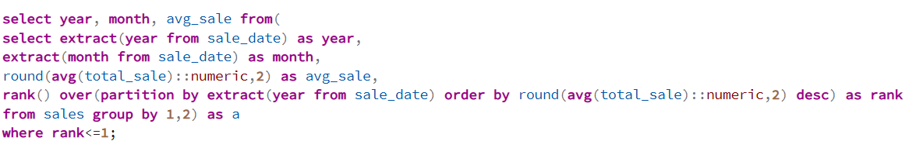
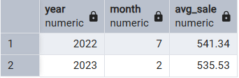
11. Write a SQL query to find the top 5 customers based on the highest total sales
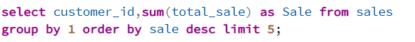
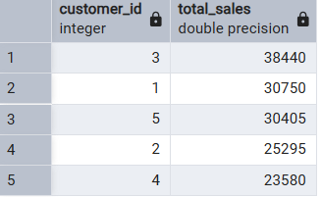
12. Write a SQL query to find the number of unique customers who purchased items from each category.
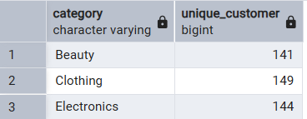
13. Write a SQL query to create each shift and number of orders (Example Morning <12, Afternoon Between 12 & 17, Evening >17)
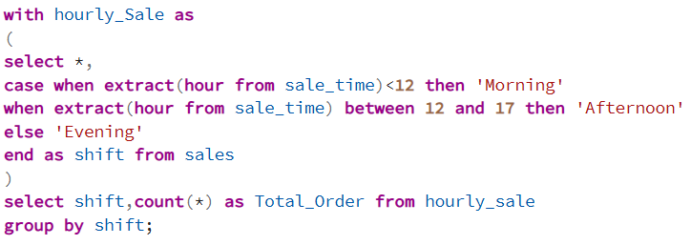
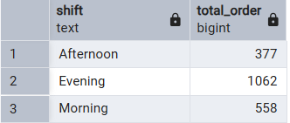

Conclusion
From the above Retail Sales Analysis, we observed the following key insights:
- The dataset contains 1997 sales records, which were used for the analysis.
- The total number of unique customers is 144.
- Customers mainly purchase products from categories such as Electronics, Clothing, and Beauty.
- On 2022-11-05, the total number of orders was 11, and the total sales revenue generated was ₹6,830.
- Among all categories, Electronics generates the highest sales, compared to Beauty and Clothing.
- Out of 1997 sales records, 306 transactions had purchases above ₹1,000, indicating high-value sales.
- Most customers buying Beauty products fall under the below 40 age group.
- The months 2022-07 and 2023-02 generated the highest sales compared to other months.
- The maximum number of orders were placed during the Evening time, showing peak customer activity.
Overall, this analysis provides useful insights into customer behavior, category performance, high-value sales trends, and peak sales periods, which can help improve business decisions such as inventory planning, marketing strategy, and customer targeting.

Thank You

